May 13, 2022

ERRATUM/ADDENDUM # 1

Invitation for Bid 9102.1

Ala Carte Offerings

Please note the following changes to the above-mentioned Invitation For Bid:

1. Under General Conditions:

A. Intent

Line Item #37463 is corrected to read 37469

F. Provision for Price Adjustment

Paragraph three is change to read:
Price increases will not be considered for the first 90 days in lieu thereof.

2. Bid opening date and time remain the same May 31, 2022 at 2:00 p.m.

3. All other terms and conditions of the bid remain the same.

AMD/skh

Please indicate your receipt of this erratum/addendum by signing and return with your bid or under separate cover.

BID 9102.11, erratum - Continued
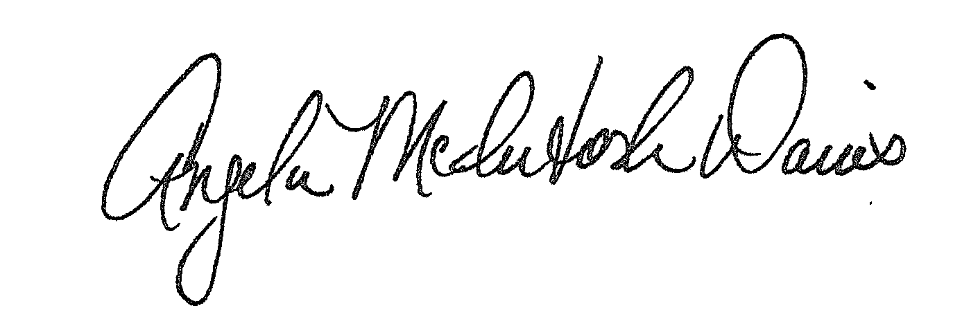

Angela McIntosh-Davis, CPPB, CPP,Team Leader Procurement Unit

Accepted:
Name and Title

Name of Company:

